Minutes of the General Meeting of the Comstock Grizzlies
Saturday September 20 @6:30 PM
Nathan and Ken’s Home

General information and attendance:

Meeting called to order @ 7:17 PM by Ken

Meeting Attendee’s: 16

Nathan, Ken, Dan, Tom, Thomas, Jason, Max,
Ron, Dean, Tat, Steve, Abe, Tim, Jim, Kyle
and Mike P.

August 2025 minutes were sent to group.

Motion to approve as sent.
Motion: Tom Second Jason Approved by acclimation.

Current information for these minutes.
Treasurers Report: Through 09/19/2025

Previous Balance: $ 635.46
Transactions: IN $ 20.00 donation
Ending Balance: $ 655.46
Net Change: $ 20.00

Motion to approve the Treasury Report.
Motion: Tom Second Thomas Approved by acclimation.

Although dues are not required to attend activities.
We are all encouraged to renew your dues
and look at friends to become members.
Just so we have funds for our club expenses.

Web/Facebook Report:

Nathan motioned for to be reimbursed for the
Club web and domain fees. Web Hosting is $215.40
Domain name is $24.95 Total is $240.35
Motion: Tom Second Thomas Approved by acclimation.
Dean paid Nathan by club check.

The Web Host fee was raised. Nathan is going to
Check into getting a reduction since we are non profit
with very light usage.

Old Business:

Summer outings are done. Hope you all had fun.

Next Dinner Night Out (DNO)

Dave & Buster's Reno
In the Summit Sierra
13969 S Virginia St, Reno, NV 89511

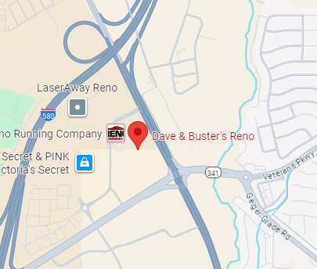
Reservation made by Nathan

Pot Luck Dinner and Club Meeting – Typically the 3rd
Saturday of the month

New Business:

Tim and Jim mentioned the variety show from the Episcopal Church on September 28th. From 2-4 Pm
Check with Tim for more information.

2025 WORLD GAY RODEO FINALS are
coming to the reno livestock
event center – October 9-12 2025



https://www.gay-rodeo.net/2025-world-gay-rodeo-finals/2025-world-gay-rodeo-finals

Cut and paste link for more information

Next Meeting:

October Meeting and Pot Luck
Nathan and Ken’s Home Sparks
Saturday October 18th @ 6:30pm

No theme for this dinner.

Hope to see you all there.

A big thank you to Thomas and Dan for covering
for us last month.

Close the meeting:
Motion: Tom, second Jason, Approved by acclimation.
Approved at 7:35 PM.

Respectfully Submitted
Nathan C. - Secretary September 24, 2025.

